Quillows- How to make a quilt in a pillow
A quillow is a quilt with a reversible pocket strategically sewn on the quilt so it can be folded up to fit inside the pocket, making a pillow. These are the perfect sleepover accessory for kids to take with them or a nice item to keep in the car on long trips. Great for a couch throw, too. Quillows can be made any size, and are fun to do in a theme such as "bugs" or "autumn."
To make a small quillow, you will need 2 yards of fabric for the top, 2 yards for the back, an 18" square for the right side of the pillow (do you have an orphan block you could use?) and an 18" square for wrong side, plus a crib size batting.
Start by placing the top and bottom pieces right sides together. Put the batting on top. Sew along all four edges, leaving a 6-8" opening. Turn your quilt inside out. Sew the opening closed. Topstitch along edges using your walking foot. Quilt or tie as desired to finish it.
To make the pillow pocket, repeat this process with the 18 inch squares. Quilt the pocket (if desired), then pin this pocket to the center bottom of the top of the quilt. Sew around both sides and the bottom, leaving the top open. That is where you will put your folded up quilt. Again, a walking foot is really helpful.
You are done! Be sure to put a label on it. If you would like to label your quillow with usage information, try this little poem:
Use me as a pillow
Unless you get cold
Then pull out my stuffing
And gently unfold
I'm a lap quilt now
With space for your feet
And when you're all done
Fold me back nice and neat
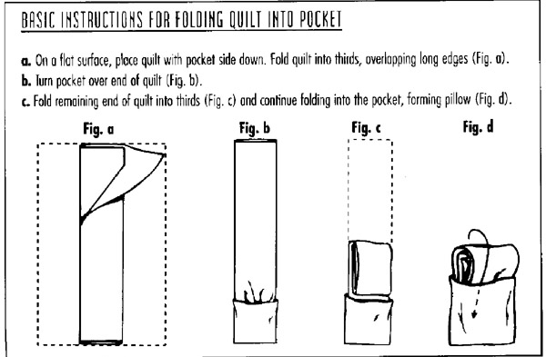
To fold it, turn the quillow over so that the pocket is on the bottom. Fold lengthwise into thirds, overlapping the center. Roll or fold the quilt into 18 inch sections. When you get to the end, the entire quilt will have been folded into an 18 inch block. Turn the pocket inside out over the top of the block, making a pillow. Now it looks like a pillow.

